**SQL Join** statement is used to combine data or rows from two or more tables based on a common field between them. Different types of Joins are as follows:

* INNER JOIN
* LEFT JOIN
* RIGHT JOIN
* FULL JOIN

Consider the two tables below:

Hello everyone, welcome to gigs for Geeks. So

Play Video

**Student**

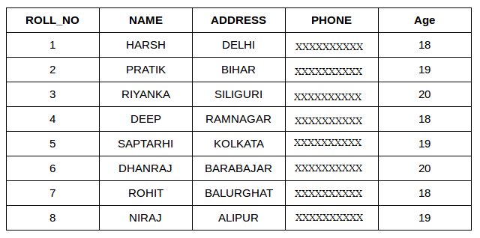

**StudentCourse**

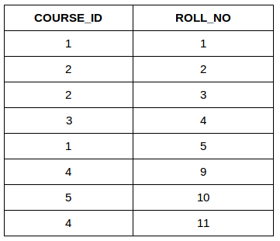

The simplest Join is INNER JOIN.

**A. INNER JOIN**

The INNER JOIN keyword selects all rows from both the tables as long as the condition is satisfied. This keyword will create the result-set by combining all rows from both the tables where the condition satisfies i.e value of the common field will be the same.

**Syntax**:

SELECT table1.column1,table1.column2,table2.column1,....

FROM table1

INNER JOIN table2

ON table1.matching_column = table2.matching_column;

**table1**: First table.

**table2**: Second table

**matching_column**: Column common to both the tables.

***Note****: We can also write JOIN instead of INNER JOIN. JOIN is same as INNER JOIN.*

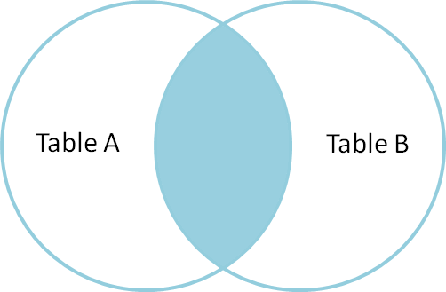

**Example Queries(INNER JOIN)**

This query will show the names and age of students enrolled in different courses.

SELECT StudentCourse.COURSE_ID, Student.NAME, Student.AGE FROM Student

INNER JOIN StudentCourse

ON Student.ROLL_NO = StudentCourse.ROLL_NO;

**Output**:

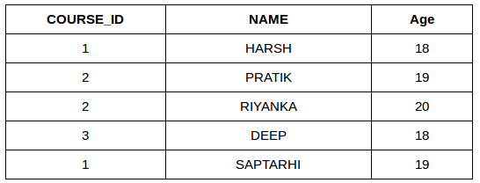

**B. LEFT JOIN**

This join returns all the rows of the table on the left side of the join and matches rows for the table on the right side of the join. For the rows for which there is no matching row on the right side, the result-set will contain *null*. LEFT JOIN is also known as LEFT OUTER JOIN.

**Syntax:**

SELECT table1.column1,table1.column2,table2.column1,....

FROM table1

LEFT JOIN table2

ON table1.matching_column = table2.matching_column;

table1: First table.

table2: Second table

matching_column: Column common to both the tables.

***Note****: We can also use LEFT OUTER JOIN instead of LEFT JOIN, both are the same.*

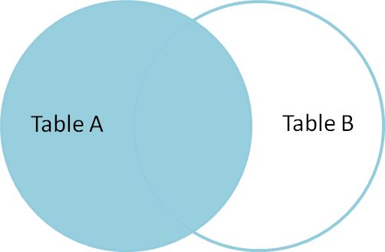

**Example Queries(LEFT JOIN)**:

SELECT Student.NAME,StudentCourse.COURSE_ID

FROM Student

LEFT JOIN StudentCourse

ON StudentCourse.ROLL_NO = Student.ROLL_NO;

**Output**:

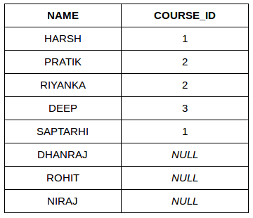

**C. RIGHT JOIN**

RIGHT JOIN is similar to LEFT JOIN. This join returns all the rows of the table on the right side of the join and matching rows for the table on the left side of the join. For the rows for which there is no matching row on the left side, the result-set will contain *null*. RIGHT JOIN is also known as RIGHT OUTER JOIN.

**Syntax:**

SELECT table1.column1,table1.column2,table2.column1,....

FROM table1

RIGHT JOIN table2

ON table1.matching_column = table2.matching_column;

table1: First table.

table2: Second table

matching_column: Column common to both the tables.

***Note****: We can also use RIGHT OUTER JOIN instead of RIGHT JOIN, both are the same.*

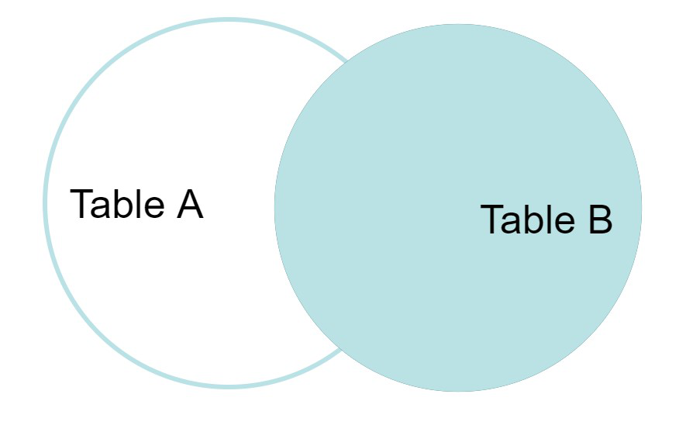

**Example Queries(RIGHT JOIN)**:

SELECT Student.NAME,StudentCourse.COURSE_ID

FROM Student

RIGHT JOIN StudentCourse

ON StudentCourse.ROLL_NO = Student.ROLL_NO;

**Output:**

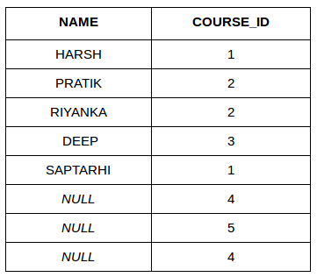

**D. FULL JOIN**

FULL JOIN creates the result-set by combining results of both LEFT JOIN and RIGHT JOIN. The result-set will contain all the rows from both tables. For the rows for which there is no matching, the result-set will contain *NULL* values.

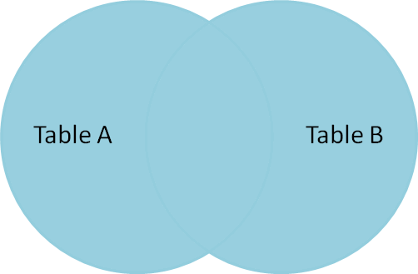

**Syntax:**

SELECT table1.column1,table1.column2,table2.column1,....

FROM table1

FULL JOIN table2

ON table1.matching_column = table2.matching_column;

table1: First table.

table2: Second table

matching_column: Column common to both the tables.

**Example Queries(FULL JOIN)**:

SELECT Student.NAME,StudentCourse.COURSE_ID

FROM Student

FULL JOIN StudentCourse

ON StudentCourse.ROLL_NO = Student.ROLL_NO;

**Output:**

| NAME | COURSE_ID |
| --- | --- |
| HARSH | 1 |
| PRATIK | 2 |
| RIYANKA | 2 |
| DEEP | 3 |
| SAPTARHI | 1 |
| DHANRAJ | NULL |
| ROHIT | NULL |
| NIRAJ | NULL |
| NULL | 4 |
| NULL | 5 |
| NULL | 4 |

In this article, we will discuss about the remaining two JOINS:

* **CARTESIAN JOIN**
* **SELF JOIN**

Consider the two tables below:  
[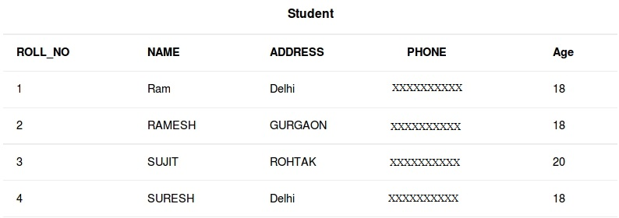](https://media.geeksforgeeks.org/wp-content/cdn-uploads/table2.jpg)

Hello and welcome to the next session of interview

Play Video

**StudentCourse**

[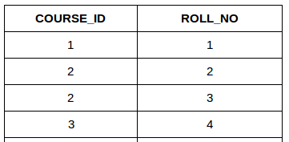](https://media.geeksforgeeks.org/wp-content/uploads/table51.png)

* 1. **CARTESIAN JOIN**: The CARTESIAN JOIN is also known as CROSS JOIN. In a CARTESIAN JOIN there is a join for each row of one table to every row of another table. This usually happens when the matching column or WHERE condition is not specified.
     + In the absence of a WHERE condition the CARTESIAN JOIN will behave like a CARTESIAN PRODUCT . i.e., the number of rows in the result-set is the product of the number of rows of the two tables.
     + In the presence of WHERE condition this JOIN will function like a INNER JOIN.
     + Generally speaking, Cross join is similar to an inner join where the join-condition will always evaluate to True

**Syntax:**

SELECT table1.column1 , table1.column2, table2.column1...

FROM table1

CROSS JOIN table2;

**table1**: First table.

**table2**: Second table

**Example Queries(CARTESIAN JOIN):**

* In the below query we will select NAME and Age from Student table and COURSE_ID from StudentCourse table. In the output you can see that each row of the table Student is joined with every row of the table StudentCourse. The total rows in the result-set = 4 * 4 = 16.
* SELECT Student.NAME, Student.AGE, StudentCourse.COURSE_ID
* FROM Student
* CROSS JOIN StudentCourse;

**Output**:  
[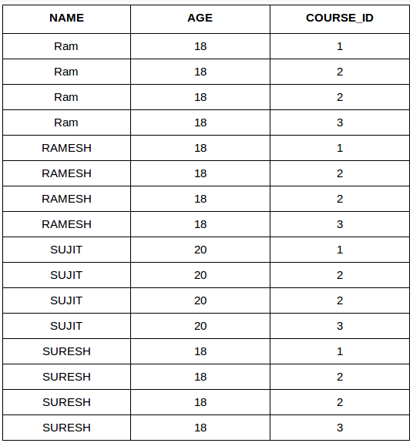](https://media.geeksforgeeks.org/wp-content/uploads/table_final.png)

1. **SELF JOIN**: As the name signifies, in SELF JOIN a table is joined to itself. That is, each row of the table is joined with itself and all other rows depending on some conditions. In other words we can say that it is a join between two copies of the same table.**Syntax:**
2. SELECT a.coulmn1 , b.column2
3. FROM table_name a, table_name b
4. WHERE some_condition;
5. **table_name**: Name of the table.
6. **some_condition**: Condition for selecting the rows.

**Example Queries(SELF JOIN):**

SELECT a.ROLL_NO , b.NAME

FROM Student a, Student b

WHERE a.ROLL_NO < b.ROLL_NO;

**Output:**  
[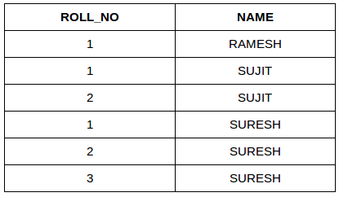](https://media.geeksforgeeks.org/wp-content/uploads/tableeee1.png)